SUPERPRO ® / 5000 Stand-alone mode instructions
SUPERPRO5000 is a multi-purpose high-speed programmer for both R&D and mass production. SuperPro5000, 5000E and 501S incorporate dual operational modes.
 PC Mode Operation: Programmer is connected to a PC via a USB port and all operation is performed through the PC. This mode is used for engineering and development as well as small volume production.
 Stand‐ Alone Mode Operation: All operation is performed through the attached keypad and display. Prior to operating in Stand‐alone mode, relevant programming data and information has to be downloaded into the programmer memory, Compact Flash (CF) card. Device programming algorithm, user data, device configuration, Auto programming sequence, etc. are conveniently combined into a project file for download, simplifying user operations. The Compact Flash card could store multiple project files as much as the memory space allows (provides data buffer area for programming). For example, a 4GB card can store hundreds of project files. This mode is used for volume production operation and this manual is only for stand-alone mode operation.
There is a LCD panel and keypad for user operation in stand‐alone mode operation. Screen menu and function list are as follows.
Keyboard Rules
ENTER - Select and enter the next menu level
EXIT - Exit to previous menu
↑, ↓ down scroll function. BUFFER change the cursor display address
→, ← BUFFER shows the selection of address bits
- RUN
Enter this menu to complete the practical operations of the device. Common features are as follow:
AUTO - Execute a sequence of functions user defined and stored in the project file. This includes one or more of the functions listed below
PROGRAM - BUFFER data will be written to the chip
READ will read the chip data in CF card, (the user project file will be changed)
BLANK CHECK checks whether the chip is empty
VERIFY- It compares the chip data and buffer data and results in error if mismatch is found
ERASE- Erases the chip.
SECURE – Protect the chip.
2. SELECT PROJECT
Press ENTER when this option appears and scroll with the ↑ or ↓ to select the appropriate project. If the project has a password, use the →, ← keys to change Bit.
3. BUFFER
1) CHECK SUM
Calculate the checksum of the buffer data and compare with the value saved last time. If they are different from each other, display the checksum values of both
2) Display BUFFER
Display the content in the buffer. Press ENTER to display start address and data and → or ← to move the cursor to the address to be modified, then use ↑ or ↓ to change the address
3) Display BUFFER 1: Shows BUFFER1 content.
4. SETTING
1) PRODUCTION MODE
When enabled, a chip inserted is checked and programming operation begins automatically. Use ↑ or↓ key to select ‚Enable‛ or ‚Disable‛. Default is ‚Enable‛. A user only has to remove a chip and insert a blank chip for automatic programming operation.
2) AUTO CHECKSUM
Checksum value is provided automatically before programming operation begins. Use ↑ or ↓ key to select‚ Enable‛ or ‚Disable‛. Default is ‚Enable‛.
3) PIN CHECK (chip and pin insertion detection)
Proper insertion of the chip is checked before programming begins. Use ↑ or ↓ to select ‚Enable‛ or‚Disable‛. Default is ‚Enable‛
4) ID CHECK (chip ID check)
Once enabled, each operation will automatically check the chip ID before the chip is inserted.
5) READ OPTION
Reads the chip content and saves into the buffer for visual inspection. Use ↑ or ↓ to select ‚Enable‛ or ‚Disable‛. Default is ‚Disable‛
6) BUZZER (buzzer)
Sounds beep at end of programming operation. Use ↑ or ↓ to select ‚Enable‛ or ‚Disable‛. Default is ‚Enable‛
7) CHIP COUNTER (chip count) Counts number of success and failure of chip programming.

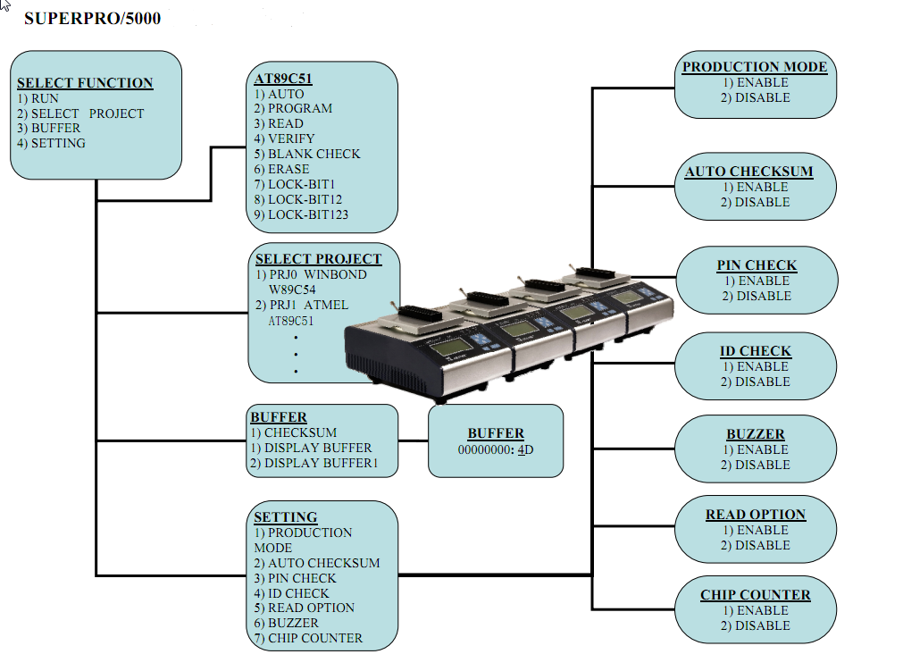

Important Information
If the buffer data is changed improperly, improper programming and loss of data may result. Please check the following advice:
 Compare the checksum in the buffer and the original project data. (usually before the production)
 READ operation may change the content in the buffer. READ function should be disabled for normal operation. Run LOAD PROJ DATA function to restore the project data

Benefits of Stand-alone programming mode:
1. User can use clusters of stand-alone programmers to achieve high volume production.
For information on cluster programming, please refer here: http://www.xeltek.com/High-Volume-Production-Clustering-pages-9
2. SuperPro Programmers in stand-alone mode can be operated by an inexperienced operator with minimal training. A project file contains all set-up and user data necessary to program a chip. There is minimal chance that an operator will make a mistake. Multiple project files can be stored in one CF card. Once the project file is selected the operator only has to insert a blank chip and remove the programmed chip upon beeping.
3. Data security is maintained by removing the Compact Flash card at the end of each operation from the programmer. If security is a concern for your manufacturing line, you may simply remove the CF card at the end of each operation day. Xeltek provides the safest application in the device programming industry.
4. Last but not the least, stand-alone mode saves the cost of PCs and saves labor cost of the trained and qualified operator.
For more information on stand-alone operation and downloading project file to a CF card, please refer to section “VI. Stand-alone Operation” in the SuperPro5000 product manual: http://www.xeltek.com/software/sp5000/sp5000manual.pdf or contact us at techsupport@xeltek.com

