Multi-programming with Xeltek SuperPro501S / 5000E / 5000 Programmers
SuperPro501S, SuperPro5000E and SuperPro5000 could be used in a multiprogramming mode for smooth transition from engineering to production.
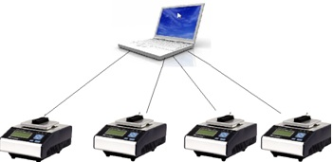
1. Install SP5000 software from the following link: http://www.xeltek.com/software/sp5000/nsp5kw.exe and obtain a Xeltek authorized USB hub.
2. Connect 1 to 4 SP5000/SP5000E programmers to a single PC via a USB hub.
3. Locate muti_p.exe in the “bin” folder from the directory where the SP5000 software is installed.
4. Run muti_p.exe and the following interface will appear.
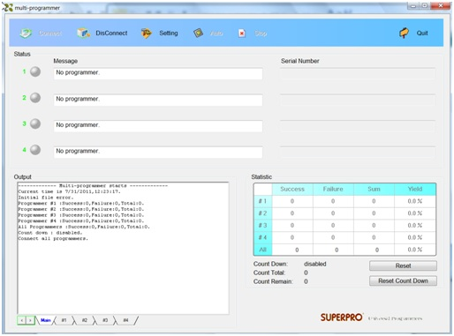

“muti_p.exe” can manage up to four programmer modules. The main screen is a management interface which controls the hardware of the programmer by sending commands to the programmer software. After the main interface, the process of communicating with the software starts automatically.
If the system does not communicate with the programmer, select Disconnect to cancel the connection. Then check the connection between the hardware and computer. Select Connect to reconnect.
“muti_p.exe” has administrator mode and producer mode. In administrator mode, users can set and save projects. Producer mode will load saved projects.

NOTE: The USB hub used to connect SuperPro programmers should be specified by XELTEK.

Benefits of using multiple SuperPro programmers in production mode:
1. Ultra-Fast programming.
2. Minimal investment in the beginning.
3. Low cost of ownership and easy expandability (1 to 4 units to a single PC).
4. Over 78,000+ devices supported, highest among the gang programmers.
5. All ranges of socket adapters available (Over 1000 socket adapters).
6. Minimal downtime and ease of service.
7. Fast new device update service free of charge.
8. Low labor cost.
For further details, please contact techsupport@xeltek.com.

