Choosing the Correct Xeltek Socket Adapter for Your Programmable Chip
Xeltek has three different methods to help you distinguish between different socket adapters and choose the most suitable one for your programmer.

- Xeltek Device Search Engine could quickly and easily help locate the suitable socket adapter for a particular programmer using the chip part number.

Click here for the Device Search demonstration.
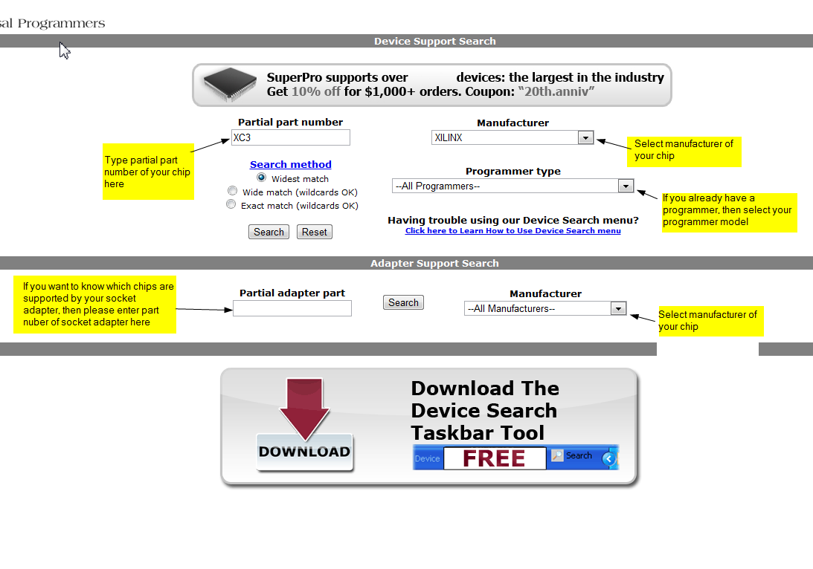

- User could check if their device is supported using the device list, such as the SuperPro5000 device list. To search, select 'Edit' --> 'Find' (shortcut: Ctrl + F) from the browser’s Menu bar. Copy and Paste the device part number into the search box and the matched part number with the socket adapter model will be highlighted.

Note: This method does not support incorrect searches, the correct chip part number must be entered. User should know the programmer model before performing a search in order to locate the correct device list.

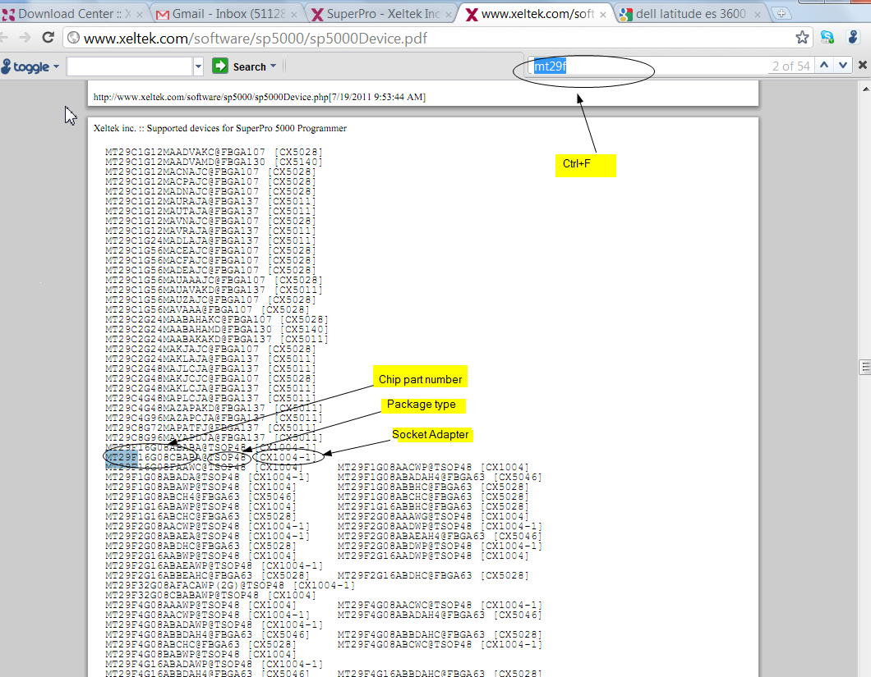
- The SuperPro programming software could also be used to locate the correct socket adapter. Download the programmer software then run software in demo mode (no hardware connected needed). Click the 'Device' button and enter the device part number in the 'Search' field.

Note: Recent device updates will not show up if programmer software is not updated.
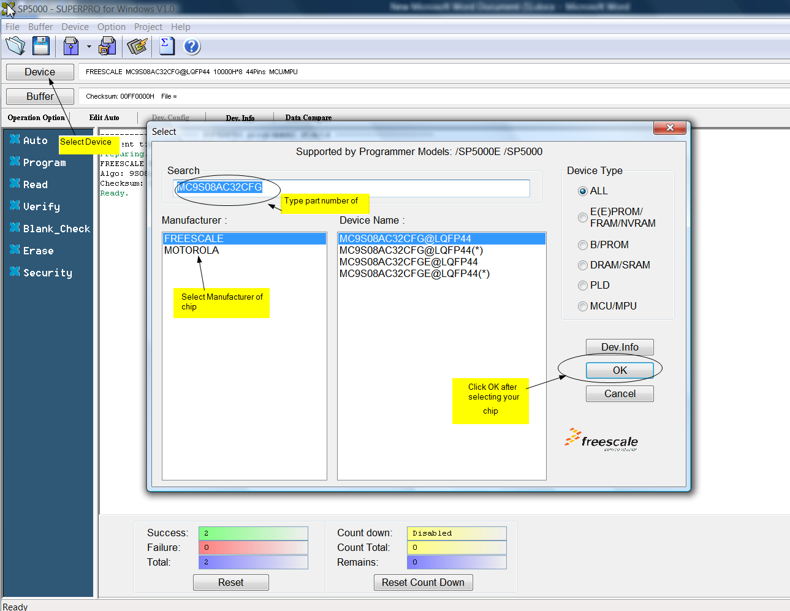
After selecting the chip part number within the software, the socket adapter information box will appear with the socket adapter information.
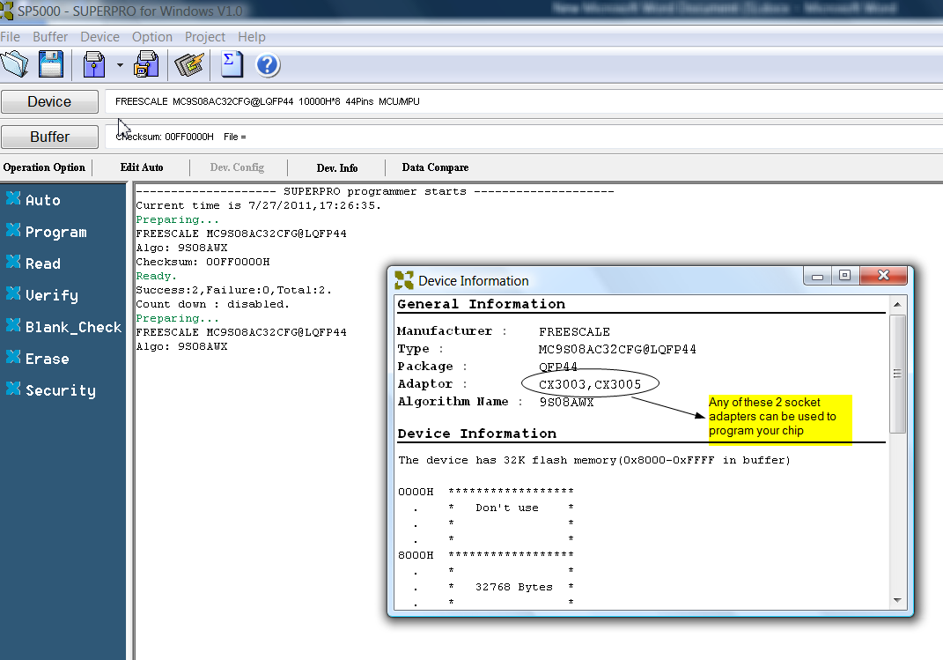
Note: 144 pin driver programmers like the SP5000, SP500E, SP5004GP, SP5004EP only support the CX series socket adapters. SP501S, SP500P, SPM and older models only support SA & TA series socket adapters.

Please contact tech support@xeltek.com or refer to FAQ for further questions.

